Falkirk Council Biodiversity Duty Report 2015-2017

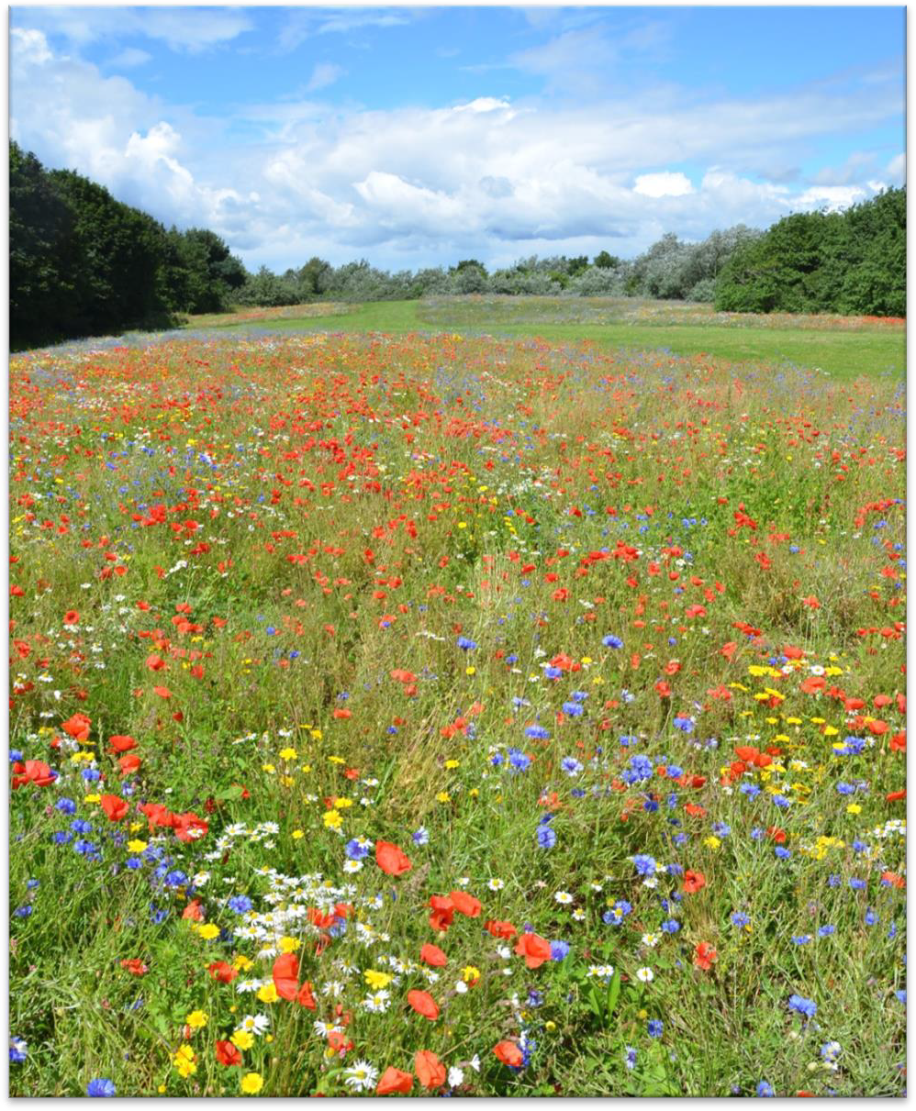

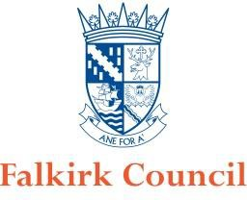

Nature Conservation (Scotland) Act 2004
Biodiversity Duty Report 2015-2017

Public Body Name | Falkirk Council
Reporting Period | 2015-2017

Introduction
Section 1.1 of the Nature Conservation Scotland Act (2004) states that “It is the duty of every public body and office-holder, in exercising any functions, to further the conservation of biodiversity so far as is consistent with the proper exercise of those functions”. This requirement is known as the Biodiversity Duty.

The Wildlife and Natural Environment Act (2011) requires all public bodies to report on their delivery of the Biodiversity Duty. Reports are to be produced and made public every three years.

This document reports on Falkirk Council’s delivery of the Biodiversity Duty for the period 2015- 2017.

It addresses the following key themes:

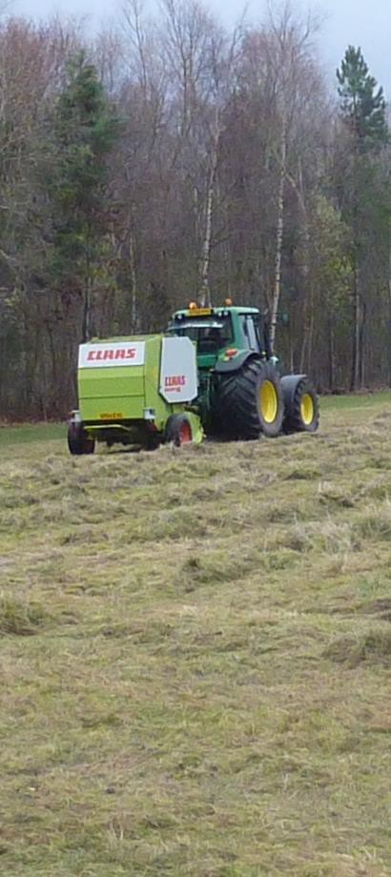
- Governance – providing clear leadership and management on biodiversity.

- Mainstreaming – integrating biodiversity into corporate projects, plans and strategies.

- Action – taking action to protect and enhance biodiversity.

- Challenges and next steps.
- Contribution to national targets.

This report is based on the knowledge of key personnel with a remit for biodiversity conservation within Falkirk Council and responses to a questionnaire returned by representatives from all Council Services.

This report will be made available on the Council’s website (www.falkirk.gov.uk), a copy can be requested from the Council’s Biodiversity Officer (E-mail: biodiversity@falkirk.gov.uk , Tel: 01324 504950), and a paper copy will also be available to view at
Development Services, Abbotsford House, David’s Loan, Falkirk, FK2 7YZ.

- Governance, Leadership and Management

Governance
Overall governance is provided by the elected Members of Falkirk Council. All policies and key strategies are reported to Council for discussion and approval. Environmental policies and initiatives are usually reported to the relevant Council committee. Progress on delivering the Local Biodiversity Action Plan and other key environmental initiatives is reported to Council periodically.

Leadership

Individual Councillors provide visible leadership with regard to environmental issues, relevant to their ward and/or their remits and responsibilities. For example:

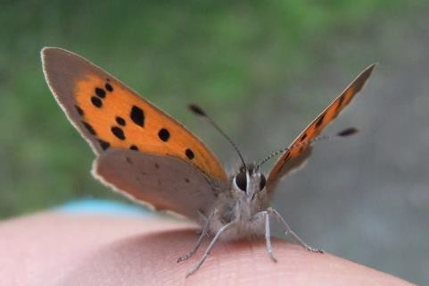
  - Attending environmental events.
  - Supporting environmental initiatives.
  - Attending community environmental events.
  - Supporting key environmental policies or programmes within the Council, such as the Local Biodiversity Action Plan and ‘Falkirk Greenspace: A Strategy for our Green Network’.
In addition the Chief Executive of Falkirk Council and relevant Directors and Heads of Service have also recognised the importance of environmental initiatives and given their support to a range of programmes and events.

Management
The Corporate Sustainability Group, chaired by the Director of Development Services, is an all service group within the Council. It has a wide ranging remit including the promotion of an understanding of the effects of climate change and its impact upon the natural environment. This requires the group to consider the health and diversity of the natural environment, how it can be enhanced and sustained, and consideration as to how climate change adaptation can be accommodated. Every Service within the Council is represented on the group by a senior member of staff. This provides a mechanism for integrating and championing sustainability issues and initiatives throughout the whole Council from the top down.
The Corporate Sustainability Group provides a mechanism that can be used to ensure all services are aware of their responsibilities under the Biodiversity Duty and are integrating biodiversity conservation into their operations.
There are additional cross-service groups which can champion and contribute to the conservation of biodiversity by Falkirk Council including the Open Space Corporate Liaison Group.

Within Falkirk Council, Development Services takes a lead role in delivering the Biodiversity Duty. The Biodiversity Officer post, seated within the Planning and Environment unit, has a specific remit to further the conservation of biodiversity through delivery of the Local Biodiversity Action Plan process. The Biodiversity Officer also provides expert advice, guidance and support to Council Services to assist and encourage actions to further the conservation of biodiversity, in line with the Biodiversity Duty.

- Mainstreaming

Plans, policies and strategies
It is essential that biodiversity conservation is incorporated into relevant plans, policies and strategies, if it is to be delivered effectively across the Council. Council plans, policies and strategies which are particularly key to furthering the conservation of biodiversity are:
  - Local Biodiversity Action Plan
  - Falkirk Council’s Environmental Policy
Other plans and policies which promote the protection and conservation of biodiversity include:
  - Sustainable Development and Climate Change Strategy 2012-2017 and Action Plan 2013-15
  - Falkirk Greenspace - A Strategy for our Green Network
  - Local Development Plan
  - Falkirk’s Open Space Strategy
  - Falkirk Forestry and Woodland Strategy
Various other plans, policies and strategies take account of their potential impact on biodiversity and seek to minimise negative impacts.

Local Biodiversity Action Plan
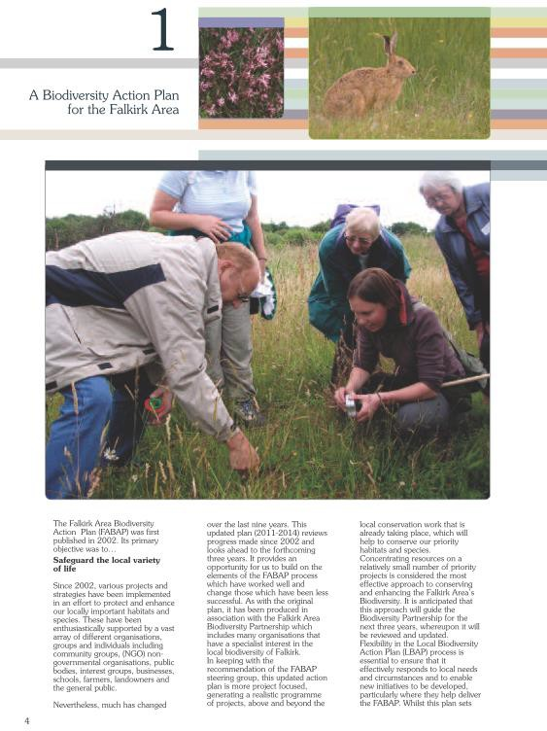
The Council is a key partner in the Local Biodiversity Action Plan process, which is co-ordinated by the Council’s Biodiversity Officer. This process aims to identify and deliver focused local action to conserve biodiversity. Input from Falkirk Council to this process is critical to achieving the goal of safeguarding our vital local biodiversity. Playing this key role in the LBAP process is a fundamental element of the Council’s fulfilment of its Biodiversity Duty.
The Falkirk Council Area has had a Local Biodiversity Action Plan process since 2000, supported by a Biodiversity Officer within Falkirk Council. Many of the actions within the Local Biodiversity Action Plan relate to Council owned land or Council initiatives.
The Local Biodiversity Action Plan is currently being reviewed and updated to reflect new challenges and focuses for local action. Stakeholder consultation has
been undertaken by the Council’s Biodiversity Officer and plan development is being progressed with a view to publishing a revised plan in 2018. A number of different Council Services and staff have already been involved in development of the forthcoming revised action plan.

The Council’s Environmental Policy
Falkirk Council’s Environmental Policy states: “Falkirk Council will conduct its business responsibly, in a way that protects the environment, actively prevents pollution and protects the health and safety of employees, visitors and local residents. Wherever it operates, it will conduct business with respect and care for both the local and global environment. It will aim to lead by example, promoting the values endorsed in this statement and co-ordinating action in the wider community.
The policy lists a number of standards and actions which the Council is committed to, including to:
- “use natural resources in a more sustainable way and aim to protect and enhance Falkirk’s wildlife and biodiversity on land managed by the Council;
- comply with all relevant environmental legislation and regulations, codes of best working practice and other recognised requirements;
- protect and enhance the natural and built environment;…”.

Procedures and processes
Specific procedures are adopted by most Services or departments within Services to ensure that they routinely assess the effects of their activities on biodiversity, adhere to environmental law and adopt environmental good practice. In some cases this is undertaken on a project by project basis rather than assessing the impacts of wider policies or strategies. However, in some instances where impacts on biodiversity may be considered, this is done on an ad hoc basis and tends to rely on the awareness and understanding of the individual staff involved.
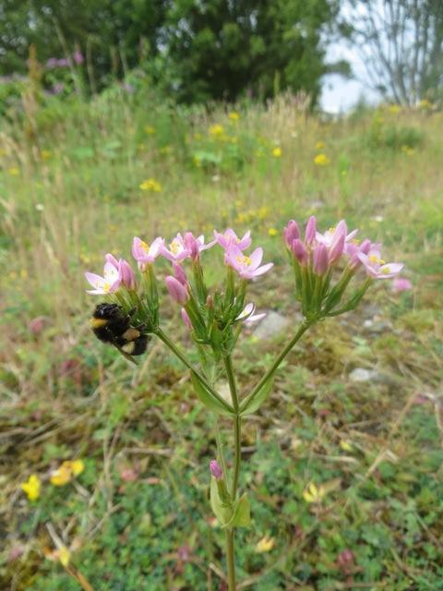
Procedures used by some Services to assess and limit impacts on biodiversity include:
- Strategic Environmental Assessment
- Consultation with the Biodiversity Officer or similar expert
- Use of ecological consultants
- Environmental Impact Assessment (where legally required)
- Pre-works ecological surveys
- Contractor and procurement standards or requirements
The Council’s committee report template has been reviewed and now includes a mandatory section which asks the author to set out the “Sustainability/ Environmental Impact” of the proposal.

Advice and Expertise
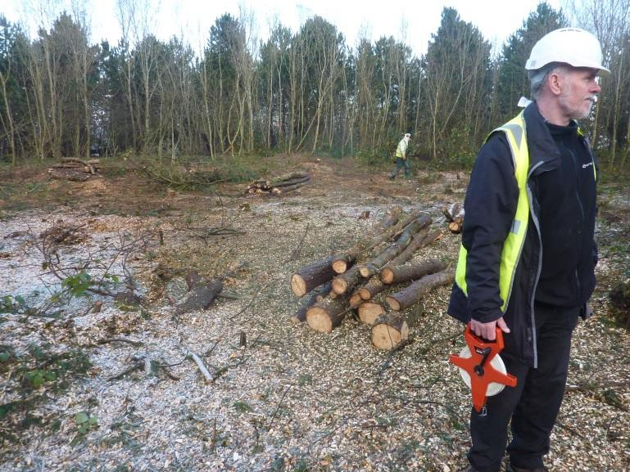
The majority of Council Services seek biodiversity advice from the Council’s Biodiversity Officer or, in some instances, from external organisations or specialist consultants. Other staff within the Planning and Environment Unit, such as the outdoor rangers, also provide expert advice to colleagues on biodiversity conservation.
Some Services have staff with specific responsibility for and knowledge of biodiversity conservation issues.
However, most rely on a general awareness of environmental issues by those staff whose remit it is most relevant to. They then access expert advice and support from elsewhere within the Council or externally as required. The availability of this advice and support is constrained by the level of specialist staff resource dedicated to biodiversity conservation and ecological issues.
Whilst several Services report not having provided biodiversity related training to staff members, those Services most likely to regularly impact on biodiversity have provided a range of relevant environmental training to some staff.

Staff Awareness
Staff awareness of the biodiversity duty within Falkirk Council is generally low. Awareness levels amongst managers and key staff remains mixed, with many Services or units reporting that most managers/key staff are aware of the Biodiversity Duty and others reporting very little awareness. There is greater awareness of more general environmental issues, opportunities and constraints. These include: environmental legislation, species protection, invasive species, and sustainable procurement. Similarly awareness of the Council’s Environmental Policy appears to be limited but there is greater awareness of the environmental policies and initiatives most relevant to individual or Service remits.
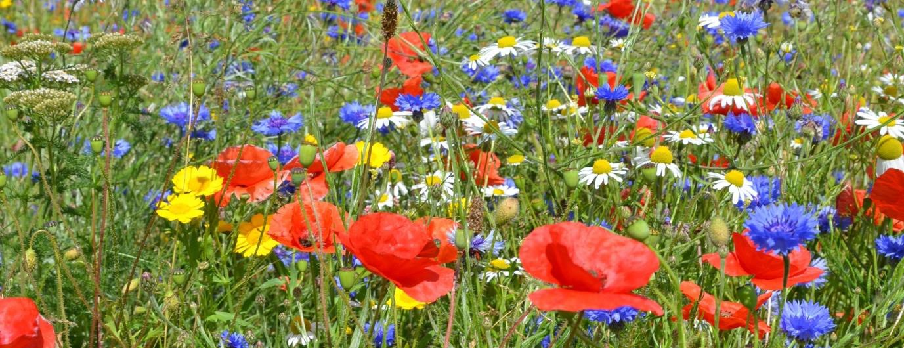

Action for Biodiversity
This section highlights the wide variety of activities undertaken by Falkirk Council to further the conservation of biodiversity over the reporting period (2015-17). While not exhaustive, it illustrates the range of activities that have taken place and continue to take place.

Adhering to environmental law
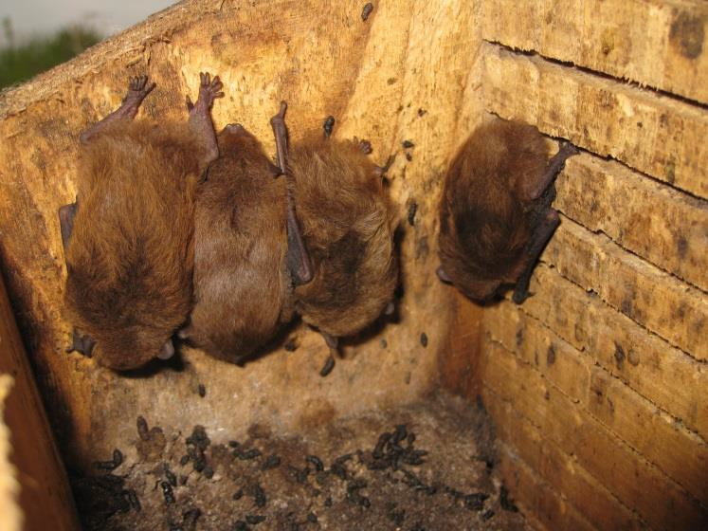
  - Continued use of a checklist to ensure contractors undertaking replacement fencing works are checking hedges for nesting birds and other wildlife prior to removing the hedge. (Corporate & Housing Services)
  - Protected species surveys undertaken at Muiravonside cemetery lodge and at the Crematorium prior to works taking place. (Development Services)
  - Bat protection plan produced and implemented during crematorium upgrade, with assistance from ecological consultants. (Development Services)
  - Appropriate ecological surveys and assessment required with planning applications likely to impact on protected biodiversity. (Development Services)
  - Japanese Knotweed surveys and control continued at the Slamannan Road Car Park site. (Development Services)
  - Work within rivers and burns scheduled to avoid fish spawning and migration periods. (Development Services)
  - Biodiversity included in framework contracts for term consultants for engineering and flooding, providing expertise in ecological issues during project design and planning. (Development Services)
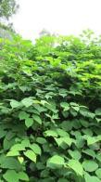
  - Bat survey undertaken by specialists prior to the Falkirk Steeple restoration works. (Development Services)
  - Residential property upgrades, to meet 2020 energy efficiency standards for social housing, have included protected species surveys and have protected and accommodated both existing and new bat roosts during roof replacement works. (Development Services and Corporate & Housing Services)
  - Tree works are avoided during the bird breeding season. (Development Services)
  - For building projects biodiversity impacts are assessed by project, with development proposals informed by protected species & habitat surveys to ensure that legal obligations are met and that the impact of the development on biodiversity is minimised (Development Services)

  - Engineering and building projects include the survey, identification and treatment of invasive species (such as Japanese knotweed) including licensed disposal where required. (Development Services)
  - Working with SEPA & fish protection organisations in relation to engineering works within watercourses/rivers etc. (Development Services)

Assessing and limiting negative impacts

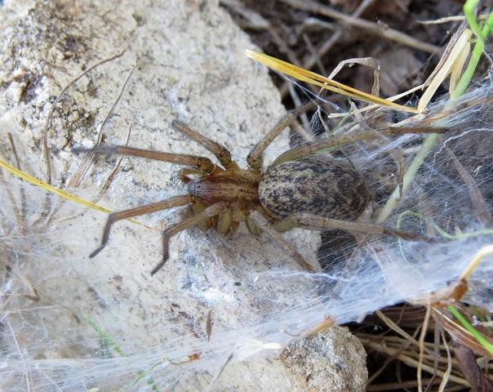

  - The Council’s committee report template has been reviewed and now includes a mandatory section which asks the author to set out the “Sustainability/Environmental Impact” of the proposal.
  - Full Strategic Environmental Assessments have been undertaken on key strategy/policy documents including the Local Development Plan, the Open Space Strategy, Supplementary Guidance 14 - Spatial Framework and Guidance for Wind Energy Development, and Supplementary Guidance 13 – Open Space and New Development (Development Services).

  - Habitat Regulations appraisals are undertaken for any projects likely to have a significant impact on Special Protection Areas (designated for their important bird populations). As the competent authority Falkirk Council undertake a significant number of these assessments. In addition several of its own policies have been subject to assessment including the LDP and Spatial Framework. (Development Services).
  - The loss of some mature trees during development of the new Carrongrange High School was mitigated by extensive new planting including trees and shrubs, and the creation of a greenroof. (Children’s Services & Development Services)
  - A two year bird survey and options appraisal including consideration of natural flood management has been done for the Grangemouth Flood Protection scheme. (Development Services)
  - Working closely with specialist advisors, we have introduced measures (including relevant surveying and compliance with license requirements) to accommodate existing bat roosts, when upgrading houses or developing new housing proposals. (Development Services)
  - On new developments, where existing natural habitat is to be disturbed, Building Design engage landscape designers to develop proposals to mitigate the level of disturbance, by management of or the introduction of new landscape features. (Development Services)
  - LDP policy ‘GN03: Biodiversity and Geodiversity’ promotes biodiversity through the planning process; promoting the assessment of ecological impacts and the mitigation of negative impacts. (Development Services)

Promoting environmental best practice
  - Procurement ensure that all timber purchased by Falkirk Council must meet specific sustainability criteria. The timber accreditation schemes ensure parts of the source forests are protected entirely to protect rare animals and plants. (Corporate & Housing Services).
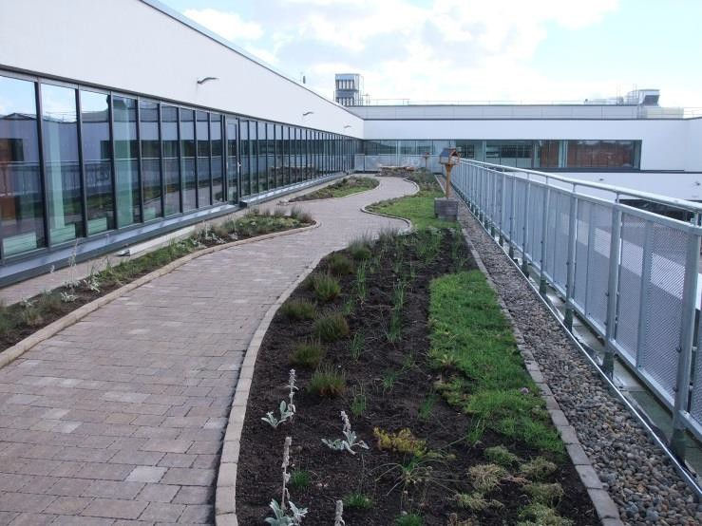
  - As part of the development of the new Carrongrange High School, a fully accessible ‘roof garden’ has been installed, a variant of our philosophy on green roofs, providing a facility that combines educational and environmental benefits. This was developed with, and funded by, Buglife, the Inner Forth landscape Initiative and the National Lottery (Development and Children’s Services)

  - Street lighting is designed and located to reduce negative impacts on biodiversity. (Development Services).
  - At a project level, officers responsible for construction projects embed relevant biodiversity decision making into their project, e.g. specific wildlife/habitat surveys & associated management or mitigation , landscape design, flood risk assessment and sustainable drainage design, and enhanced sustainable design measures (such as water management efficiency, energy efficiency, renewable technologies). (Development Services)
  - All roads schemes are considered for SUDS in terms of road drainage.

Positive action to conserve biodiversity

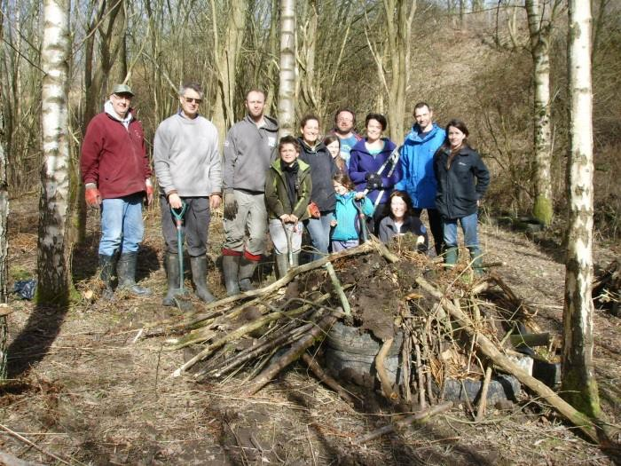
  - Services work with and support a wide range of local community groups to enhance and protect various Council owned sites of value for wildlife, including: Bonnyfield Local Nature Reserve, Polmont Woods, Maddiston Valley Park, Carron Dams Local Nature Reserve, Kinneil Foreshore Local Nature Reserve, Avonglen Quarry, Bridgeness Shipbreakers, and Westquarter Glen. (Corporate & Housing and Development Services)

  - Control of invasive species (especially Japanese knotweed and giant hogweed) is undertaken on Council owned land and at a number of other strategic locations. Private landowners are alerted to invasive species identified on their land and offered advice on appropriate treatment. (Development Services)

  - Staff and young people at Seaforth House have been developing their garden area and growing food. (Children’s Services).
  - The improvement and management of the Stenhousemuir Lido continues to ensure that the pond is an attractive feature and a valuable haven for local wildlife. (Development Services).
  - All three Local Nature Reserves are managed by local management groups with the active support of Falkirk Council. (Development Services).
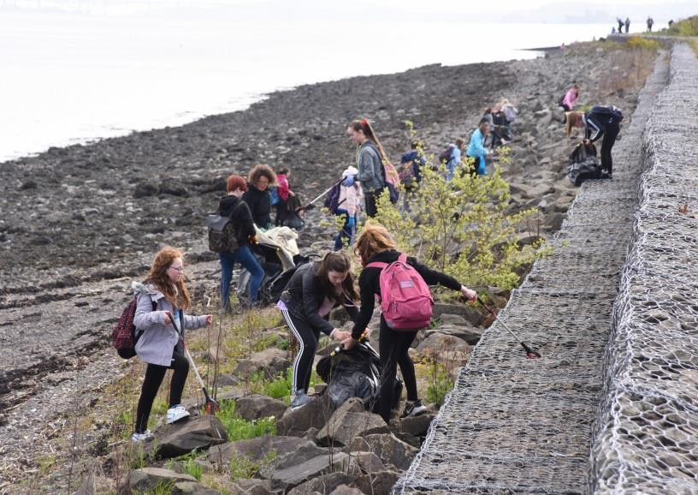
  - Communities have been supported in doing litter picks to improve their local environment. (Development Services).
  - Larbert High School is working closely with conservation organisations and the local community to protect and enhance the Carron Dams Local Nature Reserve and to use it for learning across the curriculum. (Children’s and Development Services).
  - Local Development Plan policies have been reviewed, including those relating to biodiversity, Local Nature Conservation Sites, trees, woodland, and hedges. (Development Services)
  - A Falkirk woodland strategy has been produced to guide woodland creation in the area. An
officer has been appointed (via CSGNT) to look at management and expansion of the Council’s woodland estate. (Development Services)
  - An orchard has been planted at Zetland Park. Plans for an extensive enhancement of the park have been developed and include areas of relaxed grass cutting and wetland creation. (Development Services)
  - The Local Biodiversity Action Plan process delivers a wide range of local biodiversity projects on Council land or with the direct support of council staff (including the Biodiversity Officer). Since 2015 these have included:

    - Management of a number of ecologically important sites,
    - Tree sparrow and barn owl conservation,
    - Great crested newt monitoring and habitat protection,
    - Pond conservation,
    - Work with a partnership group to deliver bog restoration across the area,
    - Management of brownfield sites including Forge Dam and Bridgeness Shipbreakers,
    - Creation and management of meadow habitat
    - A Falkirk Invasive Species Forum to raise awareness of, monitor and control invasive species,
    - Management of a rare orchid population,
    - A review of locally designated sites and identification of potential new sites
    - Work to conserve the wintering bean goose flock

    - Enhancement of estuarine habitat at several key sites along the estuary
    - Woodland management and tree planting

  - The Council protects over 80 locally designated wildlife sites and sites of importance for nature conservation. The designation system and the individual site designations have been reviewed during 2015-17 and several new sites identified. (Development Services).
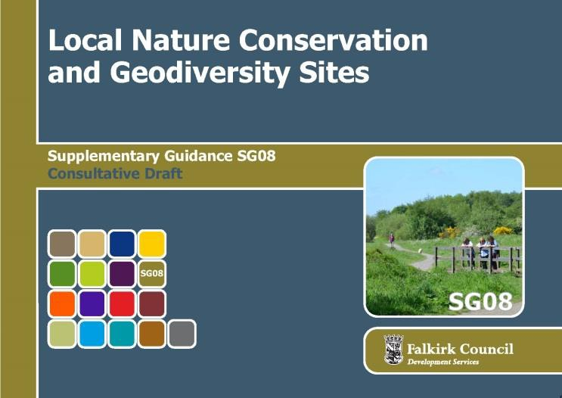
- Pupils at Larbert High School have designed several large pieces of public art, to be installed as gateway features at Carron Dams LNR. They have been inspired by the site’s natural and industrial heritage. (Development and Children’s Services)
- Supplementary Guidance No. 8: Local Nature Conservation and Geodiversity Sites has been produced to provide
guidance on the council’s suite of locally designated sites. (Development Services)

  - Work has started to look at altering grass cutting regimes in some open spaces and parks. This has significant potential to benefit biodiversity. (Development Services).
  - Falkirk Council has been a key partner in the Inner Forth Landscape Initiative and has delivered a range of biodiversity projects as part of the initiative, often in partnership with other organisations. (Development Services).
The projects have included:

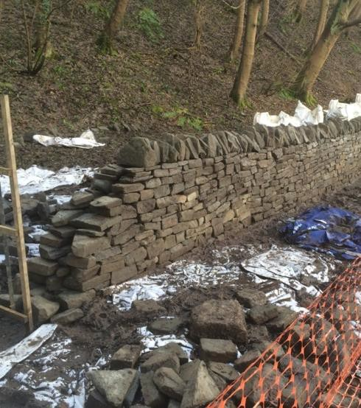
    - Habitat enhancement at Bothkennar Pools SSSI
    - Installing tern rafts at Bothkennar Pools
    - Habitat enhancement at Kinneil Foreshore
    - Meadow creation at Gangepans, Bo’ness
    - Habitat enhancement at Bridgeness Shipbreakers
    - Habitat enhancement at Polmont Woods
    - Drystone wall creation at Kinneil Estate
    - Landscape trainee team doing practical conservation projects
    - Creation of a green roof on Carrongrange High School
    - Enhancement of habitat at Garibaldi Bing
    - Wildlife recording events, training and activities

  - The Falkirk Pollinator Way project has seen work to create meadows and areas of native wildflower bulbs in a number of parks close to the John Muir Way including: Bantaskine Estate, Camelon Public Park and Policy Bing, Hallglen. (Development Services).
  - The Outdoor Rangers deliver a wide range of biodiversity projects including: school grounds enhancements, meadow creation, site management, environmental education and interpretation, wildlife camera trapping projects, and species surveying and protection. (Development Services)

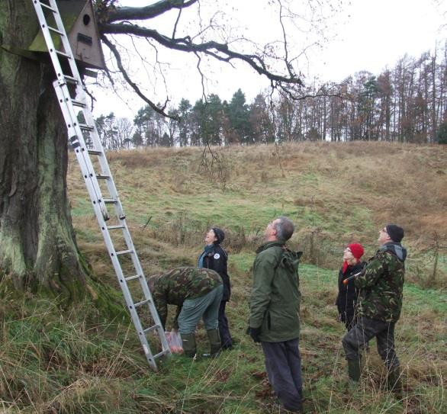
  - The Outdoor Rangers support the Falkirk Wildlife Volunteers group who undertake barn owl and tree sparrow next box projects, tree sparrow feeding, bird ringing and enhancement of Avonglen Quarry. (Development Services)
  - The Outdoor Rangers team have established a volunteer path warden programme. As well as monitoring paths, volunteer wardens have been trained to identify invasive non-native species like Japanese knotweed. They have also been given wildflower seed to sow beside paths. (Development Services)
  - Many community groups have been supported to undertake a wide range of local environmental projects. (Development, Corporate & Housing, and Children’s Services).
  - As part of commercial development proposals for the Falkirk Gateway site a masterplan has been prepared by consultants WSP which has taken full consideration of conservation of biodiversity/wildlife through the use of open water provision as part of the SUDs requirements. (Development Services)
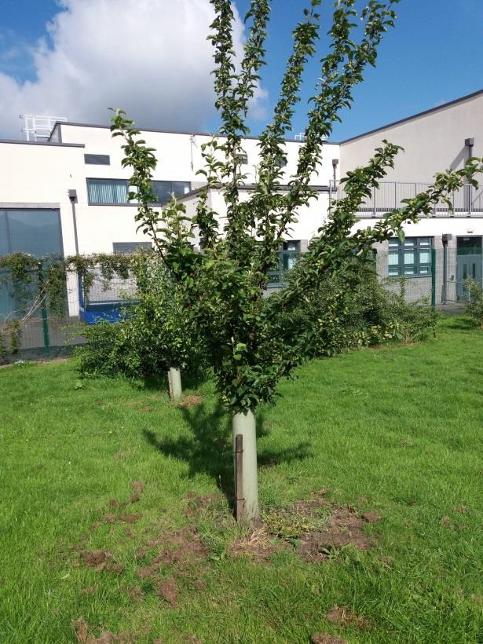
- Several schools have planted and continue to care for and use orchards within their grounds. At least 38 schools now have an orchard. (Development and Children’s Services).
- 85 Falkirk schools and nurseries are registered with Eco-schools. 40 of these currently have green flags. (Childrens Services)
- Several schools have been supported to use their local green space for outdoor learning.
(Children’s and Development Services)
- Almost all nursery, primary and secondary schools have a school garden or an outdoor learning space, where they can grow things and learn about nature. (Children’s Services)
- Grounds maintenance has reduced the use of herbicides and has undertaken bulb and tree planting. (Development Services)

  - Working with the local community and partners, Falkirk Council has developed a Masterplan for upgrading Easter Carmuirs Park. This includes tree planning, wild meadow planting and allotments. (Corporate & Housing and Development Services)
  - Work is underway to identify suitable vacant land that could be used to establish allotments. (Corporate & Housing and Development Services)
  - The Green Dog Walker scheme continues to promote responsible dog walking. (Development Services)

  - The ‘Make a Difference’ award scheme gives small grants to Council tenants groups to improve their local environment. Projects have included planting of bulbs and fruit trees and improving community gardening areas. (Corporate & Housing Services)
  - The Open Space Strategy contains a number of actions which will change the management of parks and openspace to exploit opportunities to further the conservation of biodiversity. (Development Services)

Advice, Training and Sharing Good Practice
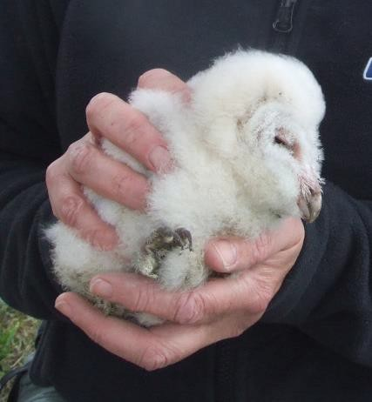
  - Training sessions on invasive non-native species identification given to volunteer path wardens. (Development Services)
  - Staff from Grounds Maintenance and Planning & Environment attended training on meadow creation. (Development Services)
  - Street lighting staff undertake Institution of Lighting Professionals (ILP) training which covers biodiversity issues. (Development Services).
  - The Biodiversity Officer and other Planning and Environment Unit staff provide expert advice on biodiversity issues to colleagues within Falkirk Council. (Development Services).
  - Supplementary Guidance on Local Nature Conservation Sites has been produced to provide advice to landowners and developers. (Development Services).
  - Staff are encouraged to attend relevant biodiversity training courses provided by other organisations such as Scottish Natural Heritage. (Development Services).
  - Training undertaken by key environment staff has included: Delivering the Ecosystem Approach, Meadow creation, Green roofs, Best practice in invasive non-native species control, Species-rich grasslands, Urban deer management, Badger surveying, and sharing good practice across the network of Scottish Biodiversity Officers.
  - Biodiversity Duty presentation given to elected members during 2015.

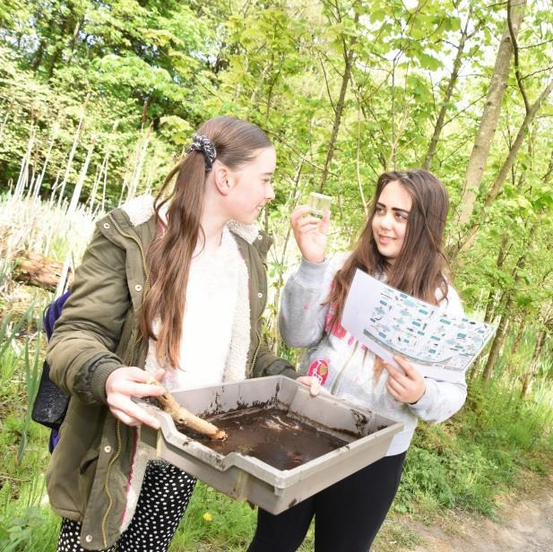
- Giant Hogweed information sheet produced to inform Council staff about the health risks and control options for this invasive species. Giant Hogweed presentation given to Roads staff. (Development Services)
- Workshop on the Biodiversity & Development SG delivered to Development Management staff. (Development Services)
- Advice provided to the flooding team about Habitat Regulations Assessments and bird survey requirements for the Grangemouth Flood Protection Scheme.

Awareness raising, communication and education
  - The Falkirk Biodiversity Newsletter is produced once a year and circulated to elected members, other Council staff, and relevant organisations and individuals. It is also made available to members of the public. (Development Services).
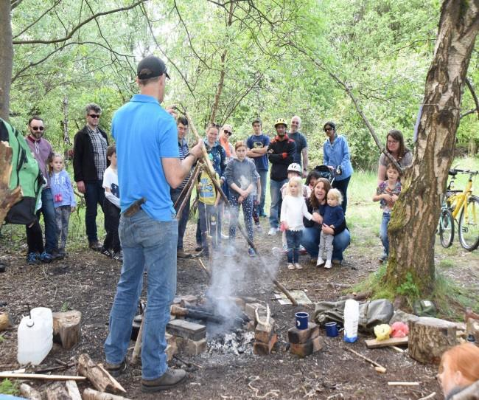
  - The outdoor rangers promote a wide range of opportunities for people to discover local biodiversity and find out more about it, through their work with schools and community groups, a programme of public events, and the provision of site interpretation. (Development Services).
  - Falkirk Council supports a variety of initiatives to promote biodiversity and encourage people to learn more about it. These have included: Naturefest, Forth Naturalist and Historian events, practical volunteering opportunities and events at our Local Nature Reserves. (Development Services)
  - Over 150 people attended the ‘Dam Fine Day Out’ at Carron Dams Local Nature Reserve in May 2017, to discover the site and find out about its wildlife. (Development Services)
  - Several schools encourage pupils to become involved in the John Muir award scheme as a means of engaging them in environmental issues and activities. (Children’s Services).
  - The Transport Planning team meetings have a fixed agenda item on sustainability to ensure regular consideration of sustainability issues. (Development Services).
  - Housing staff are encouraging tenants to take small steps to benefit wildlife within their gardens. An item in the tenant’s magazine promoted gardening to benefit wildlife. (Corporate and Housing Services).
  - A range of guidance notes, leaflets, postcards and other materials have been produced to highlight biodiversity and raise local awareness of environmental activities. (Development Services).
  - The award winning ‘Love the Lido’ Community Event, now in its 7th year, raises awareness of the Lido as an environmental asset to the community and supports local people to contribute to its long term sustainability.(Development Services)
  - The gardening competition for Council housing tenants and the Falkirk Council wide gardening competition both include a wildlife gardening category. (Development and Corporate & Housing Services)
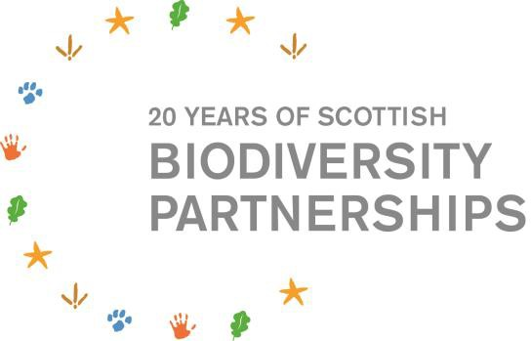
- Biodiversity and the work of Falkirk Council were promoted at a Scottish Parliamentary event to celebrate 20 years of Local Biodiversity Partnerships in Scotland (2016). (Development Services)
- 300 Larbert High School pupils undertook practical conservation tasks at a number of different sites as part of their 2017 Conservation Week. (Development and Children’s Services)

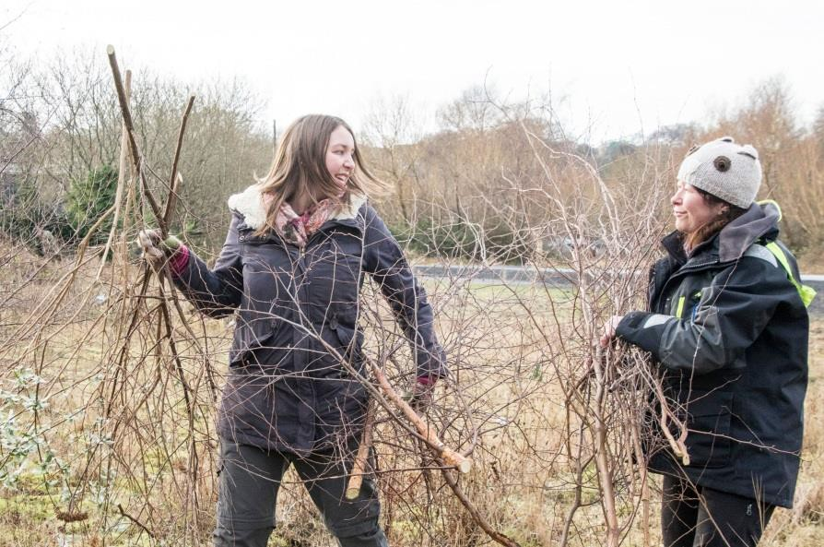
Partnership working
Many of the above activities highlight the level of joint working that is taking place between Council Services to achieve biodiversity conservation. In addition Council Services are working closely with other organisations, community groups and client groups to further the conservation of biodiversity.

The Local Biodiversity Action Plan Partnership includes a wide range of conservation organisations and individuals, as well as Falkirk Council, and demonstrates the value of partnership working.
Partnership working is critical to the delivery of local biodiversity conservation and the vast number of environmental partnership groups which the Council participates in makes it unfeasible to provide a comprehensive list in this report.
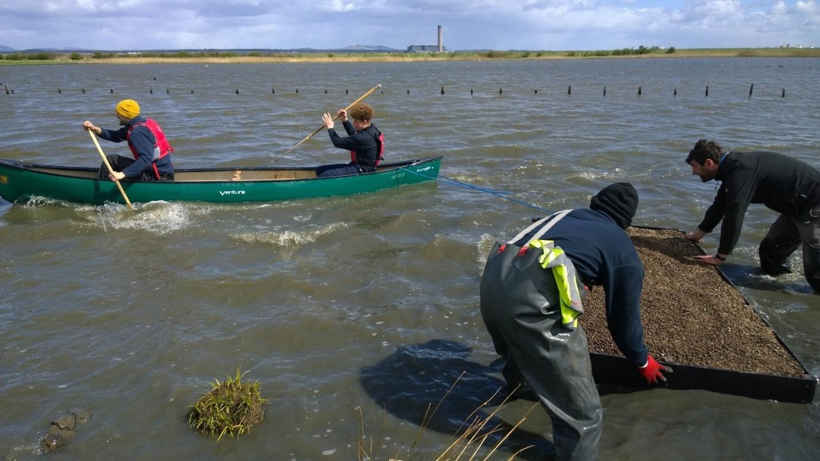

- Challenges and next steps
The Wildlife and Natural Environment Act requires Falkirk Council to report every three years on its work to further the conservation of biodiversity. This report is not only an opportunity to highlight the considerable range of biodiversity conservation activities that are already taking place, but also to highlight opportunities for improvement.
This reporting process has highlighted some potential next steps to further improve upon Falkirk Councils delivery of the Biodiversity Duty over the next three years. These include:

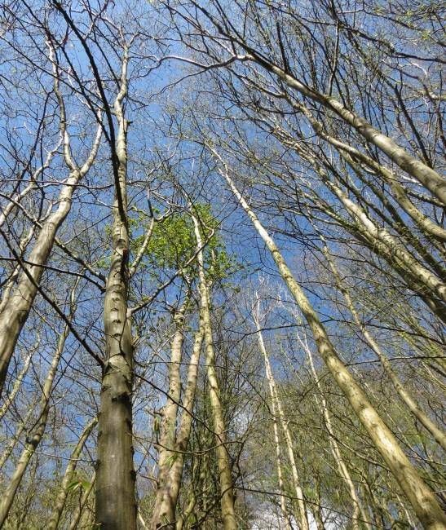
Governance, leadership & management
- Ensure that key staff involved in development and delivery of the Corporate Plan and Community Planning Partnership’s Delivery Plan are aware of where they can source environmental information, advice and support.

- Determine the potential requirement and demand for biodiversity training or awareness raising amongst elected members and senior Council staff.

Mainstreaming
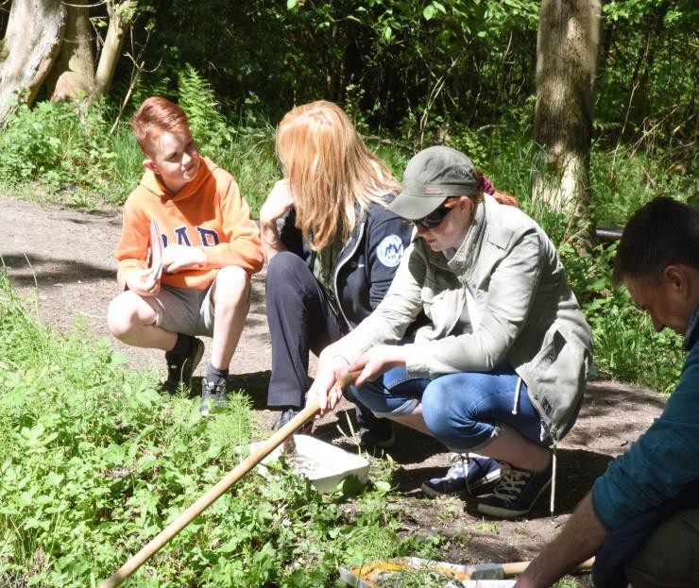
- Secure wider circulation of the Biodiversity Newsletter to relevant Falkirk Council staff, potentially with greater input from Council Services to news items.

- Ensure key staff within all services are aware of the biodiversity duty and how they can help deliver it.

- Maintain and fully resource the Biodiversity Office post, as a key mechanism for ensuring that Falkirk Council delivers its Biodiversity Duty across all Services.

Action
- Ensure that expert biodiversity advice is available to all Council Services as required, and that staff members know when and where to seek expert advice.

- Include actions for all Council Services in the forthcoming Falkirk Area Biodiversity Action Plan.

- Assist each Service to identify a small number of new biodiversity conservation actions to undertake during the period 2018-2020. Some Services have already suggested a number of specific activities, for example:

  - Identify opportunities for creating green networks in association with infrastructure projects.
  - Develop revised grass cutting regimes which will benefit biodiversity.
  - Promote measures to benefit wildlife in community growing initiatives
  - Help to signpost council staff to relevant biodiversity training opportunities
  - Investigate how biological records / protected species records can be made available to all Council Services.
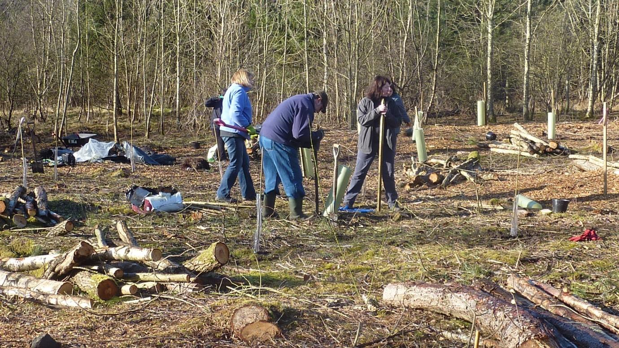

- Contribution to national targets
Falkirk Council’s work to further the conservation of biodiversity contributes to national efforts to protect and enhance Scotland’s biodiversity. The following table gives an indication of how Falkirk Council is contributing to national targets for the conservation of biodiversity (as set out in the “2020 Challenge for Scotland’s Biodiversity”.)

Targets/key steps from Chapter 1 (Healthy ecosystems) of the “2020  Challenge for Scotland’s Biodiversity” | Contribution to key step? | Justification
(1.1) Encourage and support ecosystem restoration and management, especially in catchments that have experienced the greatest degradation | Yes | Varied work to restore and manage key habitats and ecosystems including peat bog restoration, pond/wetland enhancement, control of invasive species along river systems, and protection and management of a  network of important wildlife sites.
(1.3) Government and public bodies, including SNH, SEPA and FCS, will work together towards a shared agenda for action to restore ecosystem health at a catchment-scale across Scotland | Yes | Extensive partnership working with a wide range of local and national organisations to deliver biodiversity conservation. The Local Biodiversity Action Plan provides all partners with a shared focus for local conservation  action.
(1.4) Establish plans and decisions about land use based on an understanding of ecosystems. Take full account of land use impacts on the ecosystems services that underpin social, economic and environmental health | Yes | Consideration of habitat networks, key wildlife sites and ecosystems informs the development of the LDP, the LBAP and other key policies/plans.

Targets/key steps from Chapter 3 (Biodiversity, health and quality of life) of the “2020 Challenge for Scotland’s  Biodiversity” | Contribution to key step? | Justification
(3.1) Provide opportunities for everyone to experience and enjoy nature regularly, with a particular focus on disadvantaged groups | Yes | The Council provides a wide range of opportunities for local people and groups to discover, enjoy and help to look after local biodiversity.
(3.2) Support local authorities and communities to improve local environments and enhance biodiversity using green space and green networks, allowing nature to flourish and so enhancing the quality of life for people who live there | Yes | The Council has various projects to support communities to enhance their local environments. Greenspace management is taking account of opportunities to protect and enhance biodiversity. Green network projects like the Falkirk Pollinator Way provide  benefits for both people and nature.
(3.3) Build on good practice being |  | An extensive network of paths

developed by the National Health Service (NHS) and others to help encourage greenspace, green exercise and social prescribing initiatives that will improve health and wellbeing through connecting people with nature | Yes | (monitored by volunteer path wardens) and greenspaces connect people to nature. Opportunities are provided for outdoor learning, conservation volunteering and discovering nature.
(3.4) Increase access to nature within and close to schools, and support teachers in developing the role of outdoor learning across the Curriculum for Excellence | Yes | Most schools have access to a school garden and/or orchard. Many schools are supported to use nearby greenspaces. Several schools have made very strong links to their local greenspace, helping to look after and promote it. The Local Development Plan identifies several outdoor learning  sites.
(3.5) Encourage public organisations and businesses to review their responsibilities and action for biodiversity, and recognise that increasing their positive contribution to nature and landscapes can help meet their corporate priorities and performance | Yes | Corporate volunteering has been supported on a number of wildlife sites  / LNRs. Contact has been made with a number of local businesses to discuss opportunities for involvement in local conservation projects.

Targets/key steps from Chapter 4 (Wildlife, habitats and protected places) of the “2020 Challenge for Scotland’s  Biodiversity” | Contribution to key step? | Justification
(4.1) Ensure that the management of protected places for nature also provides wider public benefits | Yes | Access provision and interpretation is provided at most council owned sites that are of importance for wildlife.  Leaflets, guided walks, events, trails, etc. are provided to actively encourage public use.
(4.3) Integrate protected areas policy with action for wider habitats to combat fragmentation and restore key habitats | Yes | As well as a suite of nationally and locally designated nature conservation sites, Falkirk Council promotes the development of wider habitat networks. This is evidenced in the LDP, the LBAP and in practical conservation  projects.
(4.5) Involve many more people than at present in this work and improve understanding of the poorly known elements of nature | Yes | Falkirk Council continues to highlight the need for biodiversity conservation amongst its staff, engage new partner organisations and community groups in biodiversity conservation, and  promote our wide range of wildlife to local people.

Targets/key steps from Chapter 5 (Land and freshwater management) of the  “2020 Challenge for Scotland’s Biodiversity” | Contribution to key step? | Justification
(5.4) Put in place the management  necessary to bring Scotland’s protected areas into favourable condition and improve the ecological status of water bodies | Yes | Falkirk Council is working to ensure that it’s SSSIs and other protected areas are under appropriate management.
(5.5) Ensure that biodiversity and ecosystem objectives are fully integrated into flood risk management plans, and restore wetland habitats and woodlands to provide sustainable flood management | Yes | The development of options for the Grangemouth Flood Protection Scheme has considered natural flood management options and will undergo a process of Habitat Regulations Appraisal.  Work to restore peatlands, protect and enhance riparian woodlands and combat invasive species along our rivers contributes to sustainable flood  management.
(5.6) Restore and extend natural habitats as a means of building reserves of carbon and to help mitigate climate change | Yes | The Falkirk bog restoration project will restore a significant proportion of the areas raised bogs. Once restored these bogs will capture carbon dioxide into the future. Protection and enhancement of other natural environments including woodland and grasslands also contribute to carbon  sequestration.
(5.7) Provide clear advice to land and water managers on best practice | Yes | Supplementary Guidance on Local Nature Conservation Sites (SG08) provides a statement for each designated site outlining appropriate management to protect and benefit biodiversity. Supplementary Guidance on Biodiversity and Development (SG05) provides guidance to developers and planners on biodiversity issues.  Advice and examples of best practice  are provided to council staff undertaking land/water management.

Images: All images provided by Falkirk Council except the following: Page 2, 4, 7, 8 (top) – Buglife, Page 6 (top) – Emilie Wadsworth.

